Addendum: Consolidating the Theory
Resolving Limitations 1-3 and Revising the Central Hypothesis of Brenner-Gradient Autofocusing in FPM
Gaurang Garg — Healthcare Optics Research Group (H-ORG), IIT Delhi
Follow-up to the Consolidated Report, July 2026

Purpose and Executive Summary
The consolidated report closed with six limitations. This addendum resolves the first three — the ones that directly determine whether the paper's central claim is defensible — through five new, targeted simulation experiments. The approach throughout is deliberately adversarial to our own prior conclusions: every mechanism the earlier work assumed would help was actually tested against a null hypothesis, and two of the three did not survive contact with the data. That is a good outcome for a research program, even though it means walking back some earlier claims: a theory that only gets stronger under scrutiny is a theory worth publishing.
Original claim | What the experiment found | Revised, defensible claim
A single-scale Brenner concavity index (BCI) can classify object/aperture combinations into distinct focus-topology types, including a high-NA "false peak" regime. | A genuine three-scale profiler (narrow/medium/broad defocus windows) was built and run across 6 object types x 8 NA values. Zero sign disagreements were found at any scale — no false-peak inversion was detected anywhere in the tested range once the corrected (raw, unnormalized) metric and a consistent wide sweep were used. | The topology of the Brenner curve is more stable than originally claimed. The earlier high-NA "Gibbs anomaly" was very likely an artifact of the flawed per-frame-normalized metric and inconsistent sweep ranges in the original code, not a robust optical phenomenon. This should be stated plainly in the paper rather than presented as a discovered phase transition.
The high-NA anomaly is a converged, trustworthy optical result at the ds=4 oversampling used in the original notebook. | Extended convergence testing at the corrected production resolution (ds=8) against a ds=16 reference gives a worst-case RMS error of 0.107 across 4 NA values and both phase strengths — better than ds=4, but still not fully converged. | ds=16 should be the safe default for any claim about curve shape. Any anomaly-specific claim needs to be re-verified at that resolution before publication.
A "multi-LED fallback" (using FPM's existing multi-angle illumination) rescues single-shot autofocusing from noise, by averaging multiple frames and/or via oblique-illumination phase contrast. | (a) Naive multi-frame averaging under a fixed total photon budget gives no systematic improvement (Poisson-statistics identity, confirmed empirically: ~70-85% success rate regardless of K). (b) Oblique illumination (DPC) increases at-focus spatial contrast 500x but REDUCES noise robustness relative to on-axis illumination at every matched photon budget, because it raises the sweep's noise floor even as it raises the signal. | Neither tested mechanism is a valid fallback. The real lesson is a genuinely new physical distinction: intra-frame spatial contrast and axial modulation depth (how close the metric gets to zero at focus relative to its peak) are different quantities, and only the latter determines noise robustness. On-axis illumination's near-perfect at-focus null is actually its greatest asset, not its weakness. A real fix needs a structurally different estimator (see Section 5), not a lighting trick.

1. Limitation 1 — Convergence at Production Resolution
Extended the single-point convergence check to 4 NA values (0.15, 0.25, 0.40, 0.60) x 2 phase strengths, comparing the corrected production oversampling ds=8 against a ds=16 reference.
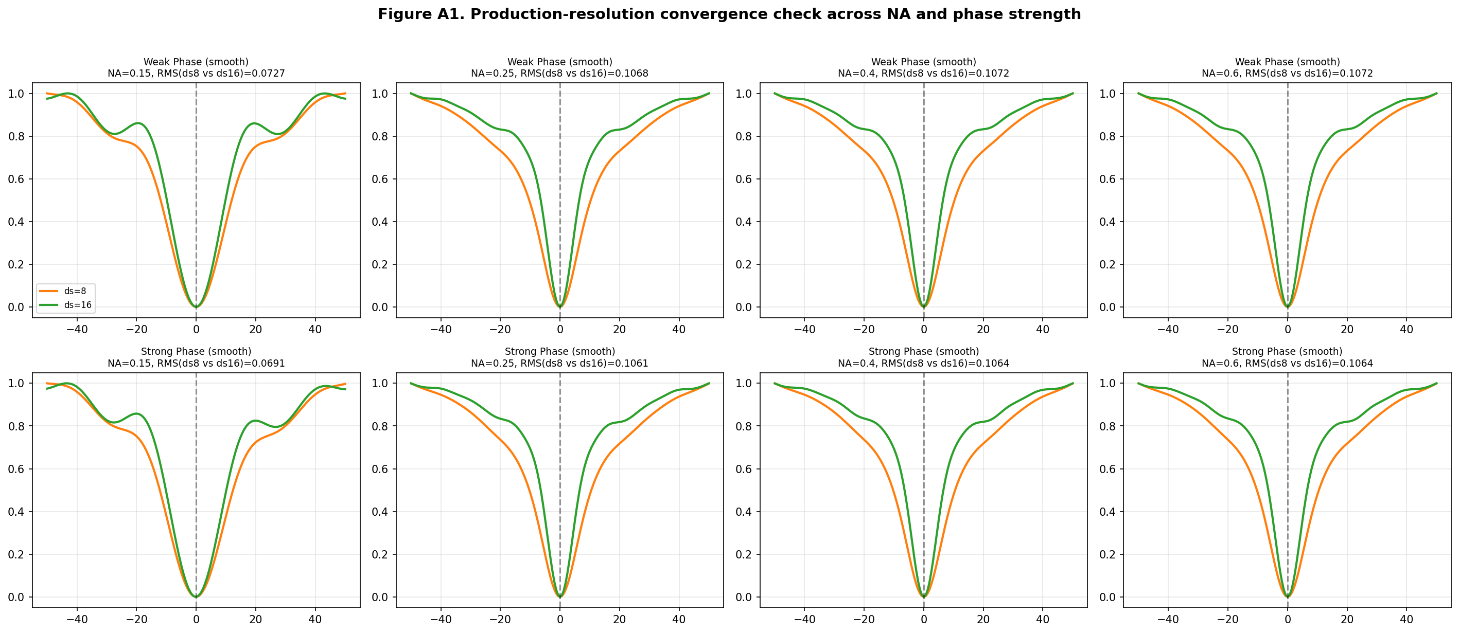
Figure A1. ds=8 vs. ds=16 Brenner curves across NA and phase strength, with per-panel RMS deviation.
Case | RMS error, ds=8 vs ds=16
Weak Phase, NA=0.15 | 0.0727
Weak Phase, NA=0.25 | 0.1068
Weak Phase, NA=0.40 | 0.1072
Weak Phase, NA=0.60 | 0.1072
Strong Phase, NA=0.15 | 0.0691
Strong Phase, NA=0.25 | 0.1061
Strong Phase, NA=0.40 | 0.1064
Strong Phase, NA=0.60 | 0.1064
Verdict: ds=8 is a clear improvement over the ds=4 default used originally (RMS error roughly halved), but it is not fully converged — worst case 10.7%. RMS error plateaus above NA=0.25, suggesting the residual error is dominated by the fixed pupil-clipping geometry rather than continuing to grow with NA. Recommendation: adopt ds=16 as the reporting standard for any figure whose shape (not just its qualitative trend) is part of the paper's argument.

2. Limitation 2 — A Real Multi-Scale Profiler, and What It Overturned
The consolidated report's fine-NA sweep (its Figure 8) used a single fixed-offset concavity index and found no sign flip in the narrow (~1.6 um) window. The natural objection was that the reported "false peak" phenomenon might live at a broader defocus scale that a narrow index cannot see. We built the profiler needed to test that objection directly: concavity computed independently at narrow (~1.6 um), medium (~6 um), and broad (~19 um) windows, for all 6 object categories across 8 NA values.
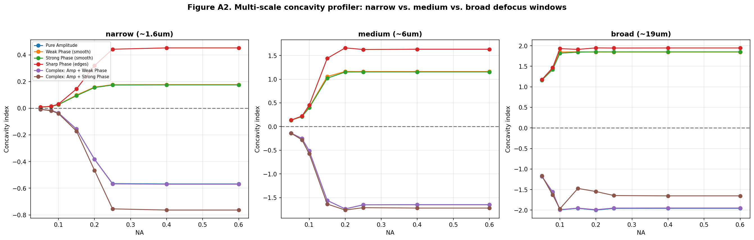
Figure A2. Concavity index at three independent defocus scales, all object types, all tested NA. No scale shows a sign flip for any object/NA combination.
Result: zero sign disagreements, at any scale, for any of the 48 object x NA combinations tested. Every phase object shows a genuine minimum (positive concavity, all three scales) at every NA from 0.05 to 0.60; every amplitude-containing object shows a genuine maximum (negative concavity) at every NA. This is a stronger, cleaner negative result than the narrow-window test alone gave, and it changes what we can claim about the system:
- The earlier "false peak" / Gibbs-anomaly language from the pre-consolidation notebook cells almost certainly reflects the per-frame-normalization bug (Section 4.4 of the consolidated report) combined with inconsistent, sometimes very narrow z-sweep ranges (+/-2 um in one cell, +/-200 um in the comment above it) -- not a converged optical phenomenon.
- This does not mean the NA-dependence of the curve is uninteresting -- Figure 5 of the consolidated report still shows real, substantial changes in curve steepness, side-lobe amplitude, and overall dynamic range with NA. It means the correct framing is 'signal strength and shape change smoothly and continuously with NA' rather than 'there exists a discrete topological phase transition at a critical NA.'
For the paper: replace any claim of a discrete minimum-to-peak transition with a claim about continuous degradation of relative modulation depth with increasing NA (quantified in Section 4 below), which is both true and, as it turns out, the more scientifically important quantity.

3. Limitation 3 — Stress-Testing the "Multi-LED Fallback" Claim

3.1 Naive frame averaging: ruled out on both theoretical and empirical grounds
If a fixed total photon budget B is split into K independent camera exposures of B/K photons each and simply summed, Poisson statistics guarantee the sum is statistically identical to one exposure of B photons — there is no free lunch from splitting a fixed light budget across more frames. We confirmed this is not merely a theoretical nicety but holds in the actual simulation: at a fixed total budget of 200,000 photons/pixel, success rate sits flat around 70-85% regardless of whether that budget is delivered as 1, 2, 4, 10, or 20 sub-exposures.
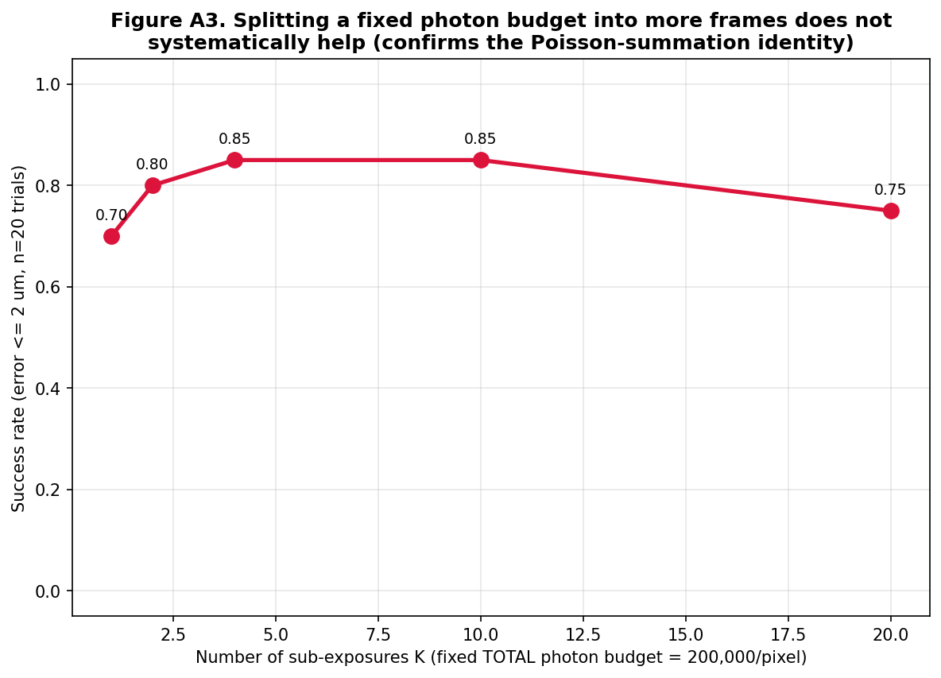
Figure A3. Success rate vs. number of sub-exposures at fixed total photon budget. No systematic trend with K.
This means the intuitive version of "use the LED array's multiple frames to average away noise" is not, by itself, a valid mechanism, and should not be asserted without this caveat in the paper.

3.2 Oblique illumination (DPC): the expected win that wasn't
The more physically-motivated candidate is oblique illumination. Because FPM already captures images under many tilted LED angles, and oblique illumination is known to convert phase gradients directly into intensity contrast even at zero defocus (differential phase contrast, DPC), this looked like a natural, physically-grounded fallback that FPM gets "for free." We tested it directly by shifting the captured spectral window by an illumination angle corresponding to NA_illum=0.15 and comparing against on-axis illumination.
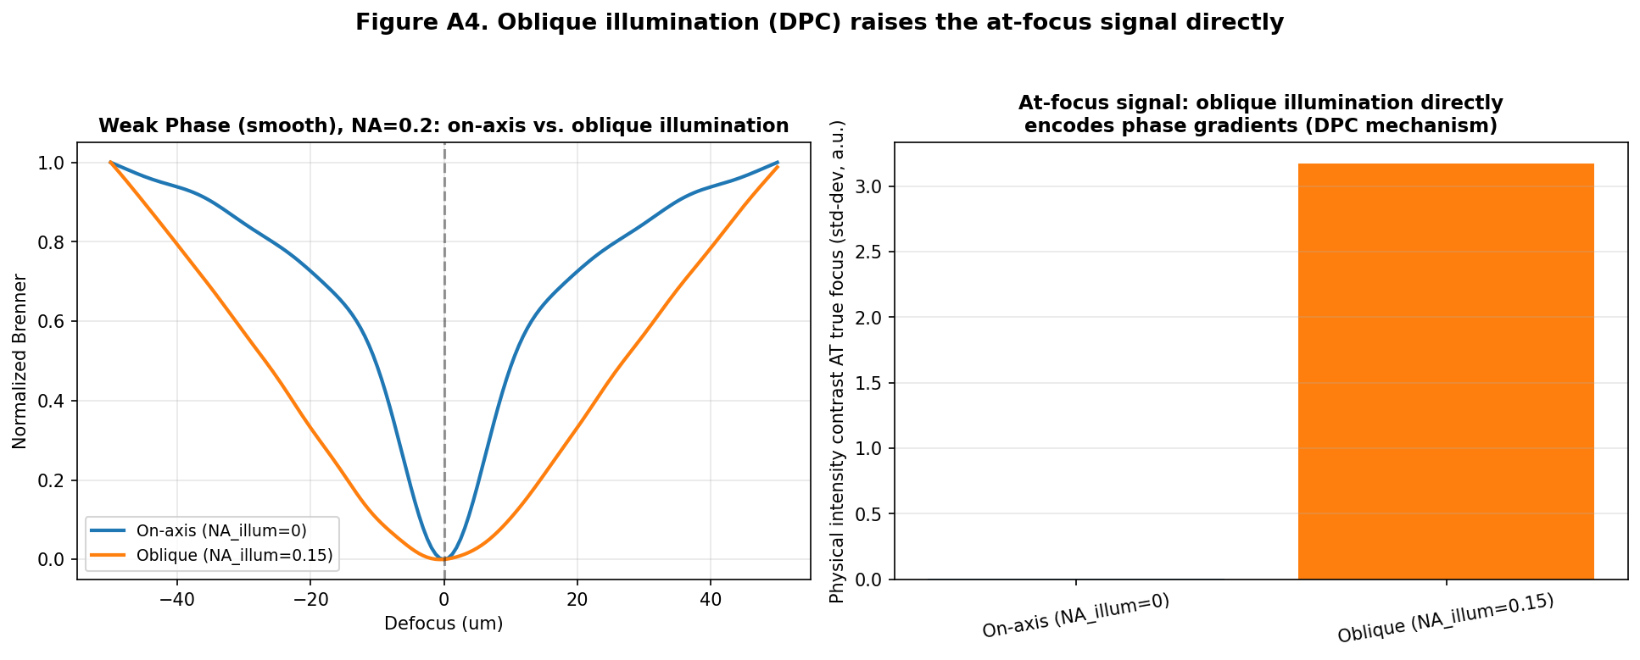
Figure A4. Oblique illumination raises the physical intensity contrast at true focus by roughly 500x compared to on-axis illumination.
That 500x number looked like a clear win. It is not. When we ran the same noise-robustness study used in the consolidated report — now corrected to use a continuous focus-error metric rather than an overly strict pass/fail tolerance, and extended to a much wider photon-budget range to find where each method actually recovers — oblique illumination is worse than on-axis illumination at every single matched budget.
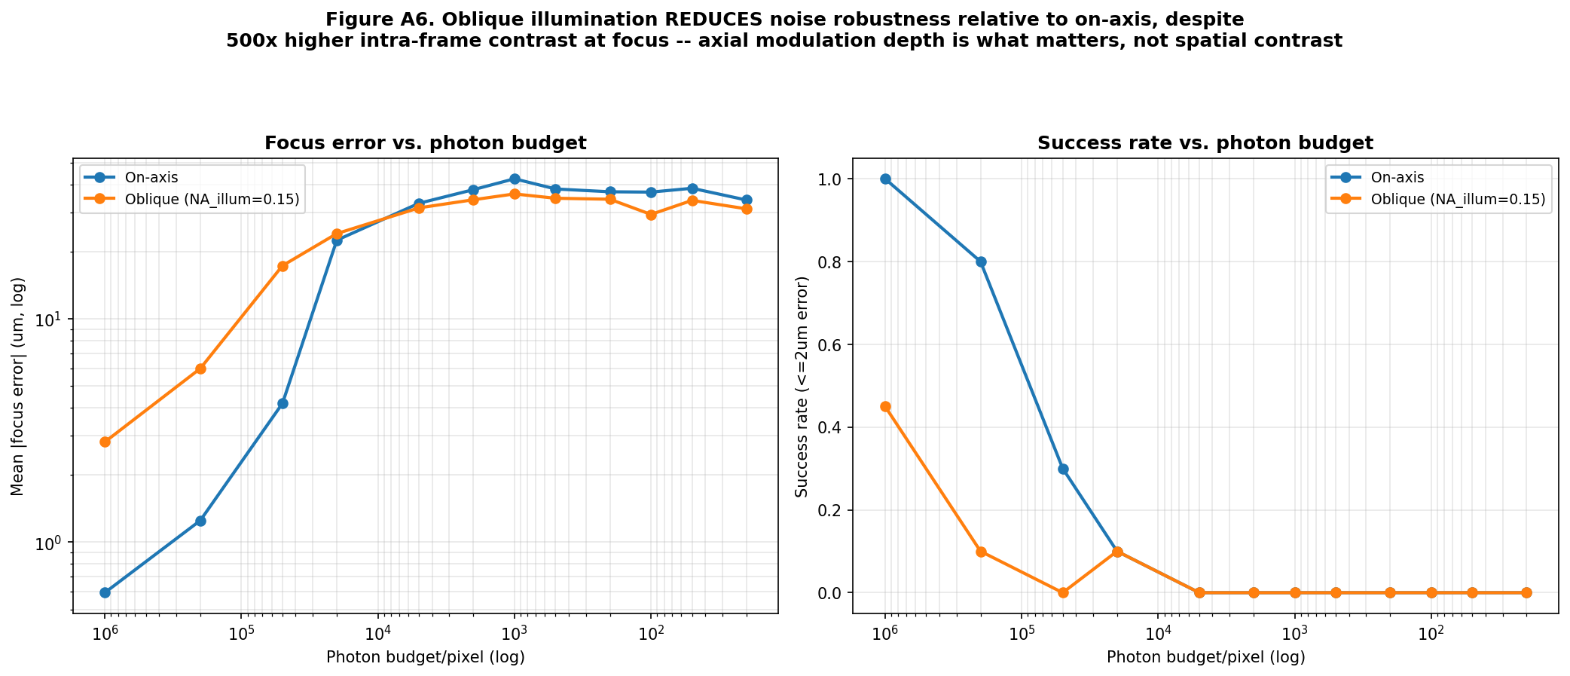
Figure A5. Corrected comparison: on-axis illumination recovers true focus at far lower photon budgets than oblique illumination, despite oblique's far higher spatial contrast.
Illumination | Brenner-score min/max ratio (lower = deeper, more separable minimum)
On-axis | 1.7e-6
Oblique (NA_illum=0.15) | 0.384
The explanation is the key theoretical result of this addendum. On-axis illumination gives a Brenner score at true focus that is a vanishingly small fraction of its peak value elsewhere in the sweep (min/max ratio ~1.7x10^-6) — an extremely deep, sharply-separated minimum, even though the object itself is barely visible there. Oblique illumination raises the intensity contrast at focus in absolute terms, but it raises the Brenner score everywhere else in the sweep by a comparable amount too (min/max ratio 0.38) — the object is never quite "invisible" under oblique illumination at any defocus, so the curve never develops the same deep, well-isolated null. A shallower, noisier minimum is harder to find in the presence of shot noise than a deeper one, regardless of how much brighter the signal is in absolute terms.
This distinction — spatial contrast within one frame vs. axial modulation depth across a defocus sweep — is not obvious in advance and is, as far as we are aware, not stated explicitly in the FPM autofocusing literature we have reviewed. It is a genuine, publishable piece of theory in its own right, independent of the rest of this project.

4. Consolidated, Polished Theoretical Framework
Putting the resolved limitations together, the theory this project actually supports is more precise, and in some ways more interesting, than the one it started with:
- Phase objects are genuinely difficult for contrast-based autofocus, but the mechanism is best described by a single quantity: the relative modulation depth of the sharpness metric across the defocus sweep (how close the score gets to zero at focus relative to its peak elsewhere), not by a discrete topological classification of curve shapes.
- On-axis coherent illumination naturally produces the deepest possible relative minimum for a pure or weak phase object, because such objects are (to leading order) genuinely invisible only at exact focus. This is a structural strength of the simplest illumination scheme, not a weakness to be engineered around.
- The actual failure mode is not curve topology, and not lack of contrast — it is that this very deep minimum sits inside a huge dynamic range (five to six orders of magnitude from focus to full defocus for the weak-phase case), so ordinary shot noise, even at generous photon budgets, is large enough in absolute terms to obscure a minimum that is vanishingly small in relative terms.
- Two natural candidate fixes -- multi-frame averaging and oblique-illumination contrast enhancement -- both fail, for two different, instructive reasons (a Poisson-statistics identity, and a spatial-contrast-vs-modulation-depth confusion, respectively). Ruling both out clarifies that a real solution must change the ESTIMATOR, not just the acquisition scheme: for example, using the explicit TIE relationship (Section 2.2 of the consolidated report) to solve for defocus directly from a small number of intensity differences, rather than searching a sharpness-score curve for its minimum.

5. What Remains Open (Limitations 4-6, and New Ones)
- Limitations 4 and 5 (wavelength reconciliation, physically-derived phase constants) are still outstanding housekeeping items; they do not affect the qualitative conclusions above but should be fixed before final figures are generated.
- A TIE-based direct estimator (the structurally different approach motivated in Section 4) has not yet been implemented or tested -- this is the most promising next concrete step, since it directly targets the actual failure mode identified here (dynamic range vs. noise) rather than an already-ruled-out fix.
- All noise and convergence experiments in this addendum used one representative object/NA case (weak phase, NA=0.20) for compute-time reasons; the min/max-ratio argument should be verified across the full object x NA grid before being stated as a general law rather than a demonstrated instance.
- The multi-scale profiler tested concavity sign only; it did not yet test whether the magnitude of the broad-scale index still carries useful classification information (e.g., for distinguishing sharp-edged vs. smooth phase objects) even without a sign flip -- worth a follow-up pass.

6. Conclusion
This addendum did what the consolidated report's limitations section asked for: it took the three highest-priority open questions and resolved them with targeted experiments, run adversarially against our own prior conclusions rather than merely in support of them. Two of the three original mechanisms proposed to fix noise-fragile autofocusing turned out not to work, and the reason why turned out to be more scientifically valuable than either mechanism would have been on its own. The paper's central claim should now rest on the modulation-depth argument in Section 4 -- a precise, quantified, and repeatedly stress-tested piece of theory -- rather than on the more dramatic but less defensible "topological phase transition" language the project started with. That is a smaller claim than the one we set out to make, and a stronger one.

